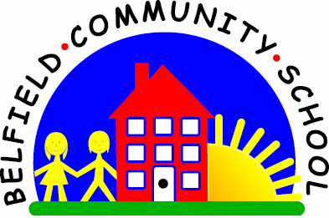



**RHE Annual Curriculum Map**

**Belfield Community School**

**RHE Annual Curriculum Map**

|  |  |  |  |  |  |  |  |  |
| --- | --- | --- | --- | --- | --- | --- | --- | --- |
| **Curriculum Map - Autumn Term** | | | | | | | | |
| **Term** | **Nursery** | **Reception** | **Year 1** | **Year 2** | **Year 3** | **Year 4** | **Year 5** | **Year 6** |
| **Autumn 1** | Families and People who care for me | Families and People who care for me  Mental Wellbeing | Families and People who care for me  Mental Wellbeing | Families and People who care for me  Mental Wellbeing | Families and People who care for me  Mental Wellbeing | Families and People who care for me  Mental Wellbeing | Families and People who care for me  Mental Wellbeing | Families and People who care for me  Mental Wellbeing |
| **Autumn 2** | Respectful Relationships  Caring Friendships | Respectful Relationships  Caring Friendships | Respectful Relationships  Caring Friendships | Respectful Relationships  Caring Friendships | Respectful Relationships  Caring Friendships  Changing Adolescent Bodies | Respectful Relationships  Caring Friendships |
| **Curriculum Map - Spring Term** | | | | | | | | |
| **Spring 1** | Respectful Relationships | Respectful Relationships | Online Relationships  Internet Safety and Harms | Online Relationships  Internet Safety and Harms | Online Relationships  Internet Safety and Harms | Online Relationships  Internet Safety and Harms | Online Relationships  Internet Safety and Harms | Online Relationships  Internet Safety and Harms |
| **Spring 2** | Being Safe  Basic First Aid | Being Safe  Basic First Aid | Being Safe  Basic First Aid | Being Safe  Basic First Aid | Being Safe  Basic First Aid | Being Safe  Basic First Aid |
| **Curriculum Map - Summer Term** | | | | | | | | |
| **Summer 1** | Caring Friendships | Caring Friendships | Health and Prevention  Physical Health and Fitness  Healthy Eating  Drugs, Alcohol and Tobacco | Health and Prevention  Physical Health and Fitness  Healthy Eating  Drugs, Alcohol and Tobacco | Health and Prevention  Physical Health and Fitness  Healthy Eating  Drugs, Alcohol and Tobacco | Health and Prevention  Physical Health and Fitness  Healthy Eating  Drugs, Alcohol and Tobacco | Health and Prevention  Physical Health and Fitness  Healthy Eating  Drugs, Alcohol and Tobacco | Health and Prevention  Physical Health and Fitness  Healthy Eating  Drugs, Alcohol and Tobacco  Changing Adolescent Bodies |
| **Summer 2** |

In the PSHE Association Toolkit Planning there is also the theme of Living in the Wider World – whilst not identified specifically in our plans, this theme is woven throughout topics such as online safety and work on respectful relationships within the Community.

Key: Physical Health and Mental Wellbeing / Relationships